- Brute force search to find path through maze
- Until
  - Cannot find any solution (despite using all possible combinations)
  - Find a path (meet ‘STOP’ square)

- All header files completed
- assig_three220.c + node.c completed
  - Can change values in assig_three220.h
    - TRACING à to keep track (printf) steps
    - DEPTH_FIRST à to change to breadth_first (in game_tree.c)
    - SHOW_PROGRESS à to show progress while working through the maze
- Need to complete
  - stack.c + queue.c easy
  - square_state.c easy
  - game_state.c not hard
  - t_node.c not hard
  - game_tree.c most difficult (majority of the challenges)

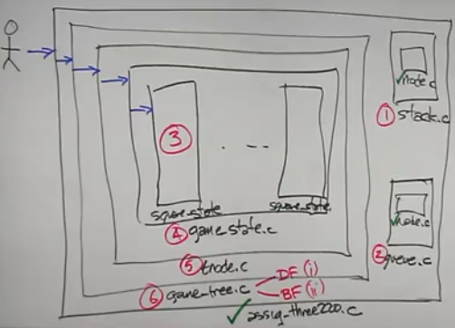
- assig_three220 contains game_tree
  - game_tree contains many t_node
    - t_node.c contains other t_node + game_state
      - game_state contains lots of square_state
        - game = 2D array of squares (rows + columns)
Remember
          - rows, columns start at 1
          - array starts at 0
            - Array [row – 1] [col – 1]

- game_tree.c has 4 functions to complete:
  - generate_level() for both BF and DF
  - build_game() for both BF and DF

- game_tree à 2 approaches – Need to do both
  - Depth first – using stack.c
  - Breadth first – using queue.c
(they are nearly identical – if 1 works – the other one has to work)

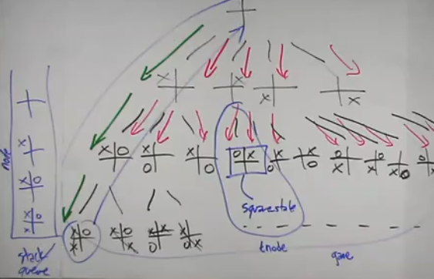
NOTE:
- game_state.c
  - Not sure if bool valid() function done correctly

